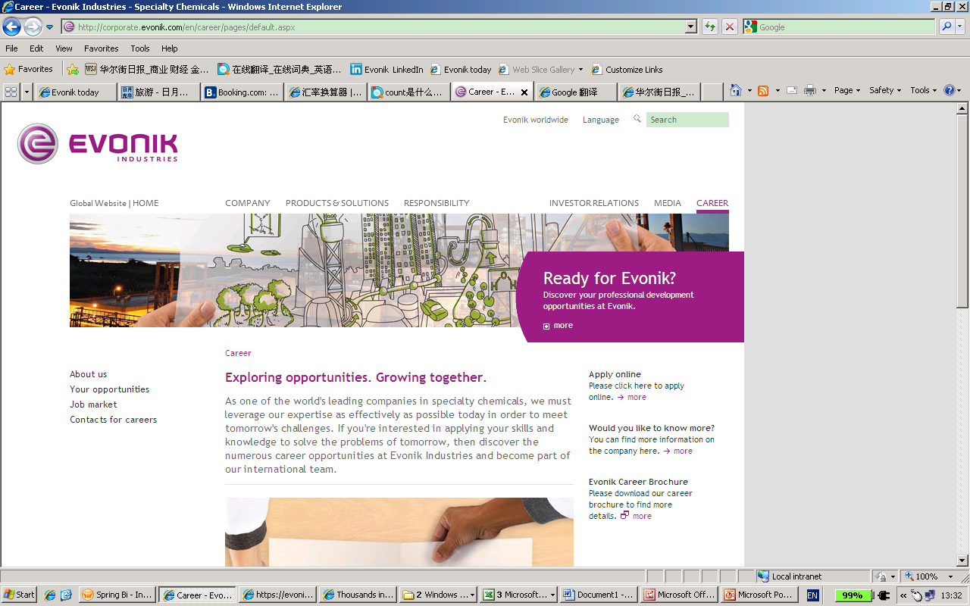

Evonik Industries, the creative industrial group from Germany, is one of the world leaders in specialty chemicals. Profitable growth and a sustained increase in the value of the company form the heart of Evonik’s corporate strategy. Its activities focus on the key megatrends health, nutrition, resource efficiency, and globalization. Evonik benefits specifically from its innovative prowess and integrated technology platforms.

Evonik has been producing specialty chemical products in the Greater China region (Mainland China, Hong Kong and Taiwan) since the late 1970’s. Evonik regards Greater China as one of the driving forces of the global economy and we consequently endeavor to grow our business in the region. Evonik regards people as the most important assets for our sustainable growth strategy.

Job Description

Position Title: | [Senior Technical Sales Manager for Probiotics]
Working Location: | Beijing or Guangzhou
Geographical Coverage: | Greater China

PURPOSE OF POSITION

- To develop China market of probiotics through development and deployment of advanced animal health and food safety concepts and technologies

PRINCIPLE ACCOUNTABILITY

- Be a leader leading a team of technical sales to develop market of probiotics:
  - Working to position Evonik as an expert in animal health
  - Working to position Evonik as a strategic resources of products and services for animal feed producers and farms
  - Establishing sustainable relationships with scientific opinion leaders as well as customers’ decision makers
  - Generating value for customers by researching and applying tailored solutions
  - Managing focus accounts for growth and profitability
- Execute technical marketing strategies of probiotics
- Do annual budget and action plan of technical activities in promoting probiotics
- Develop technical service tools and coach technical sales and commercial sales force in application of technical services tools
- Provide input and feedback on all technical issues to Regional Director of Technical Sales to steer technical services in the region
- Assist Regional Director of Technical Sales to validate commercial market estimations and predictions from a technical point of view
- Cooperate with Animal Nutrition Services in HQ in order to
  - Establish and execute nutritional researches
Maintain scientific professional contacts and supervise research projects

REQUIREMENTS

- PhD majored in Animal Nutrition
- Excellent oral English;
- 50% business travel all around China.
- Strong Leadership, initiative, self-motivation, self-learning

YOUR APPLICATION
As a global leader in specialty chemicals, we believe that it is not a question of how things are, but how they could be. Do you think so too? Then be part of our international team. Learn more about the countless opportunities at: www.evonik.com/careers

联系人：Helen Huang
Email: Job.china@evonik.com;helen.huang@evonik.com
电话: 021 -6119 1565

