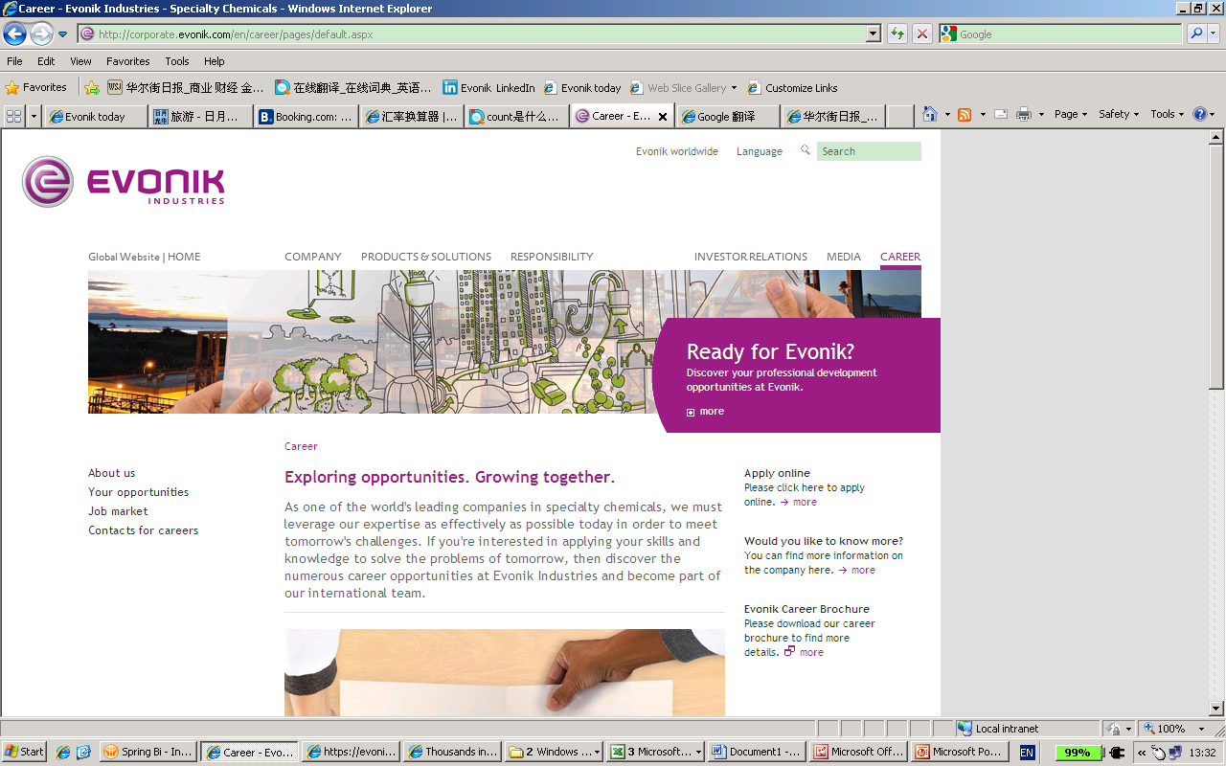

Evonik Industries, the creative industrial group from Germany, is one of the world leaders in specialty chemicals. Profitable growth and a sustained increase in the value of the company form the heart of Evonik’s corporate strategy. Its activities focus on the key megatrends health, nutrition, resource efficiency, and globalization. Evonik benefits specifically from its innovative prowess and integrated technology platforms.

Evonik has been producing specialty chemical products in the Greater China region (Mainland China, Hong Kong and Taiwan) since the late 1970’s. Evonik regards Greater China as one of the driving forces of the global economy and we consequently endeavor to grow our business in the region. Evonik regards people as the most important assets for our sustainable growth strategy.

Job Description

Position Title: | [Technical Sales Manager-Amino Acid]
Working Location: | Beijing or Guangzhou
Geographical Coverage: | Greater China

PURPOSE OF POSITION

To develop market of amino acids through development and deployment of advanced nutritional concepts and technologies

PRINCIPLE ACCOUNTABILITY

- Be a key contact in the region to provide technical supports to develop supplemental amino acids:
  - Working to position Evonik as an expert in amino acid nutrition as well as applied technology in animal feed industries
  - Working to position Evonik as a strategic resources of products and services for feed producers
  - Establishing sustainable relationships with scientific opinion leaders as well as customers’ decision makers
  - Generating value for customers by researching and applying tailored solutions
  - Managing focus accounts for growth and profitability
- Execute technical marketing strategies of supplemental amino acids in animal feed industries
- Do annual budget and action plan of technical activities in promoting supplemental amino acids in animal feeds
- Deploy technical service tools and coach commercial sales force in application of technical services tools
- Provide input and feedback on all technical issues to Regional Director of Technical Sales to steer technical services in the region
- Assist Regional Director of Technical Sales to validate commercial market estimations and predictions from a technical and animal nutritional point of view
- Cooperate with Animal Nutrition Services in HQ in order to
  - Establish and execute nutritional researches
Maintain scientific professional contacts and supervise research projects

REQUIREMENTS

- Master with 5+years working experience or fresh PhD majored in Animal Nutrition;
- workable oral English;
- 50% business travel all around China.

YOUR APPLICATION
As a global leader in specialty chemicals, we believe that it is not a question of how things are, but how they could be. Do you think so too? Then be part of our international team. Learn more about the countless opportunities at: www.evonik.com/careers

联系人：Helen Huang
Email: Job.china@evonik.com;helen.huang@evonik.com
电话: 021 -6119 1565

